Task 6

Experimental protocol & design (4 marks)

Experimental design is a method of research in which experimental factors are subjected to special

Experimental design is a research approach in which experimental components are exposed to particular treatment for comparison reasons.

Experimental design is a concept that is used to efficiently arrange, conduct, and evaluate the findings of experiments, ensuring that as much relevant information as possible is gathered by executing a minimal number of trials.

Creating a set of techniques to test a hypothesis systematically is what experimental design entails. A successful experimental design necessitates a thorough grasp of the system under investigation.

For example, the experiment looks into two independent variables: age and Augmented Reality usage.

The variable "age" contains three levels: participants between the ages of 18 and 25, people between the ages of 26 and 40, and people above the age of 40. The second variable has two levels: receiving information without Augmented Reality and receiving information with Augmented Reality. As a result, there are a total of six conditions in this experiment.

Because three groups of individuals from various age ranges are researched, the influence of age is evaluated using a between-group design. A within-group technique can be used to investigate the impact of AR use. We may assign the identical information collection assignment to each participant both with and without the aid of the AR Web-App. This results in a standard split-plot design with a between-group component (age analysis is based on the columns) and a within-group component (AR use is analysed by comparing condition 1 with condition 4, condition 2 with condition 5, and condition 3 with condition 6).

2022. [online] Available at: <https://www.merriam-webster.com/dictionary/experimental%20design> [Accessed 12 April 2022].

Djuris, J., 2013. *Computer-aided applications in pharmaceutical technology*. Oxford: Woodhead Publishing, pp.31-56.

Base, K. and design, A., 2022. *A guide to experimental design*. [online] Scribbr. Available at: <https://www.scribbr.com/methodology/experimental-design/> [Accessed 12 April 2022].

2. Independent variables & Dependent variables (5 marks)

The cause is the independent variable. Its value is unaffected by the other factors in your research. In experimental research, an independent variable is one that you control or modify in order to investigate its effects. It is referred to be "independent" since it is unaffected by any other factors in the research.

The effect is the dependent variable. Its value fluctuates in response to changes in the independent variable. A dependent variable is one that changes as a result of the modification of the independent variable. It's the outcome you're after, and it "depends" on your independent variable.

For example, Roy, S.G. & Kanjilal, U. (2021) conducted quantitative research to find the performance of the webbased AR applications using the four independent variables.

The purpose of this experiment study was to evaluate web-based AR programs’ performance on  
mobile devices with low-end hardware configuration supporting WebGL and WebRTC. To test how  
the frames per second (fps), request animation frame (raf) and load time (lt) (Independent Variables) to performance (p) (Dependent Variable), effect when changing smartphones with different memory (RAM) and processor (CPU) (Control Variables).  
The independent variables will be defined by downloading content and recording fps and raf  
variables.

Base, K. and variables, I., 2022. Independent and dependent variables. [online] Scribbr. Available at: <https://www.scribbr.com/methodology/independent-and-dependent-variables/> [Accessed 12 April 2022].

Roy, S.G. & Kanjilal, U., 2021. Web-based Augmented Reality for Information Delivery Services: A  
Performance Study. DESIDOC Journal of Library & Information Technology, 41(03), pp.167–174.

3. External validity of an experiment & Sampling types (4 marks)

The amount to which the findings of a research may be generalized to other circumstances, persons, places, and measurements is referred to as external validity.

External validity is classified into two types: demographic validity and ecological validity.

Population validity relates to whether you can properly generalize your sample's findings to a wider group of people (the population).

The term "ecological validity" relates to whether or not the findings of a research can be properly generalized to other circumstances and locations in the "real world."

When conducting research on a group of individuals, it is unusual to be able to obtain data from every member of that group. Instead, you choose a sample. The sample is the set of people who will actually take part in the study.

To draw meaningful inferences from your findings, you must carefully consider how you will pick a sample that is typical of the entire group.

Probability sampling and non-probability sampling are the two types of sampling procedures.

For example, a research was conducted to suggest a blended strategy for efficiently gathering design guidance for AR using crowdsourcing.

The results of this study show that crowdsourcing context information for adaptive AR is not only feasible, but also efficient. Today, web-based AR allows users to quickly access a wide corpus of persons and environments. Even well-equipped labs with a large number of AR devices would struggle to capture the varied variety of surroundings documented by this study's participants in such a short time period.

At this early stage of AR user interface development, the potential gains in external validity provided by the AR crowdsourcing technique for receiving evolving design guidance is a critical contribution.

Base, K. and validity, U., 2022. *Understanding external validity*. [online] Scribbr. Available at: <https://www.scribbr.com/methodology/external-validity/> [Accessed 12 April 2022].

Base, K. and methods, A., 2022. *An introduction to sampling methods*. [online] Scribbr. Available at: <https://www.scribbr.com/methodology/sampling-methods/> [Accessed 12 April 2022].

Dudley, J., Jacques, J. and Kristensson, P., 2021. Crowdsourcing Design Guidance for Contextual Adaptation of Text Content in Augmented Reality. *Proceedings of the 2021 CHI Conference on Human Factors in Computing Systems*,.

4. Coding (3 marks)

The act of collecting unstructured material and classifying excerpts methodically in order to uncover themes and patterns for study is known as qualitative coding. Coding is often done throughout the research's analysis and report writing phases. Transcriptions, audio recordings, notes, and observations can all be utilized to analyze qualitative data. Codes are labels or tags that are given to text fragments. They can be used to paragraphs, sentences, phrases, or words. Coding enables the researcher to be methodical and rigorous, to discover quotes quickly, to identify patterns and themes, and to check for biases.

For my research I will be using an inductive approach for coding, which means that appropriate codes need to be derived from the observation from my data. This is because I am discovering how users explore with new AR Technology. By doing this approach I am allowing codes to be derived from what I see from the data observed.

One research, for example, employed coding techniques to reveal certain structures and traits. Pieces of data are labeled to summarize and categorize the available data. Coding provides a means of organizing, organising, and analyzing large volumes of data. They are distinguished by the several named codes that comprise this category's multiple sub-dimensions (cf. Figure 1). These codes, as previously said, are intrinsically linked to the data.

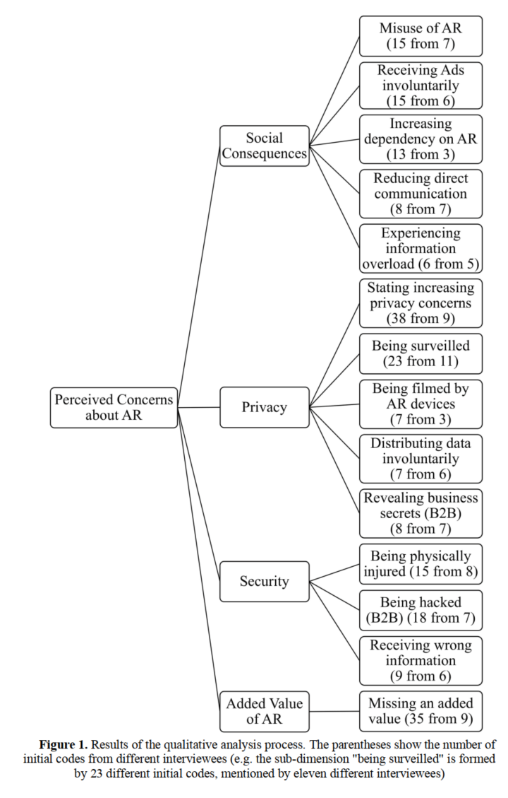

Delve. 2022. *Free Qualitative Data Analysis Course — Delve*. [online] Available at: <https://delvetool.com/course> [Accessed 12 April 2022].

Harborth, D. (02 2019) ‘Unfolding Concerns about Augmented Reality Technologies: A Qualitative Analysis of User Perceptions’, στο.

5. Research triangulation (3 marks)

Triangulation is a technique for improving the credibility and validity of study findings. The term credibility refers to trustworthiness and the degree to which a study accurately reflects or assesses the concept or ideas being studied; validity is concerned with the extent to which a research accurately reflects or evaluates the concept or concepts being investigated. By mixing theories, techniques, or observers in a research project, triangulation can assist guarantee that basic biases caused by the use of a single method or observation are addressed. Triangulation is also an attempt to examine and describe complicated human behavior utilizing a number of ways in order to provide readers with a more balanced explanation. It is a data validation process that may be utilized in both quantitative and qualitative investigations.

Triangulation can enhance research by providing a range of datasets to explain various elements of an interest topic. It also aids in the refutation of cases when one dataset invalidates a hypothesis established by another.

It can aid in the confirmation of a theory when one set of findings confirms another set of data. Finally, triangulation might aid in explaining the findings of a study. The idea behind triangulation is that methodologies that provide the same results increase trust in the study findings.

The datasets' results are studied individually, but they must also be compared to one another in some way. The methodological framework utilized determines how they are compared. Triangulation is one strategy for combining datasets, and there are three types of triangulation: (1) convergence, (2) complementarity, and (3) divergence or dissonance.

For example, Research where participants are being observed to use an Augmented Reality Application prototype, and afterwards will have an interview. If the participant observed took some time to get the hang of how the prototype works and then in the interview said that they felt that the UX can be improved. The observation and the interview answers correspond with each other. If the interview and the observation do not match, it would be a divergence or a dissonance.

Noble, H. and Heale, R., 2019. Triangulation in research, with examples. *Evidence Based Nursing*, 22(3), pp.67-68.